Project 3:

Step 1: Create two linux instances,Use the first free linux AMI

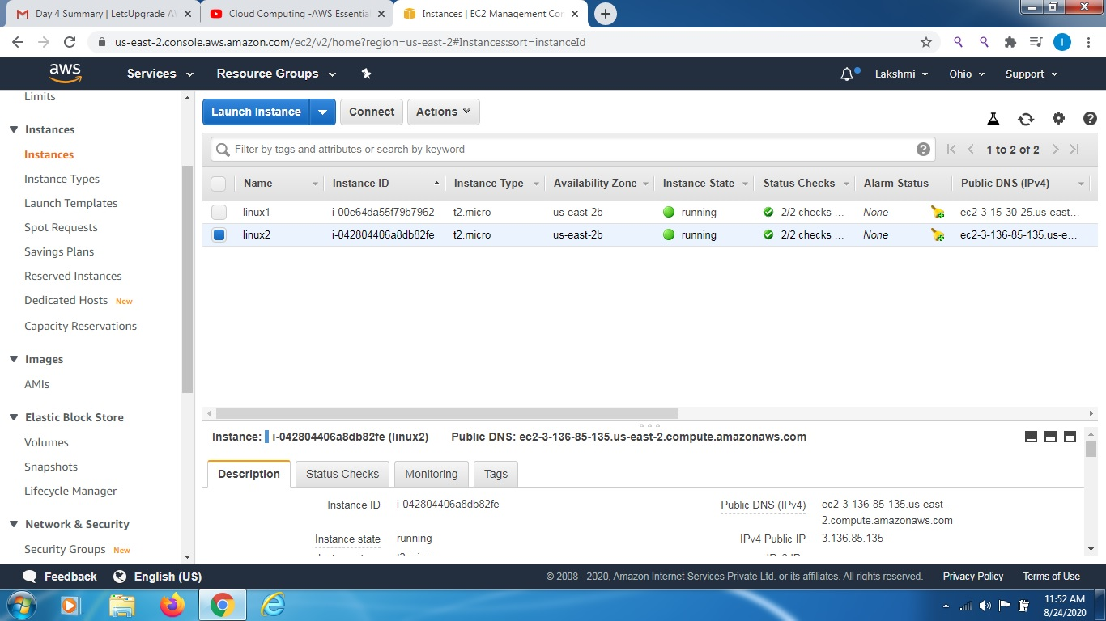

Step 2: Launch both instances using Mobaxterm

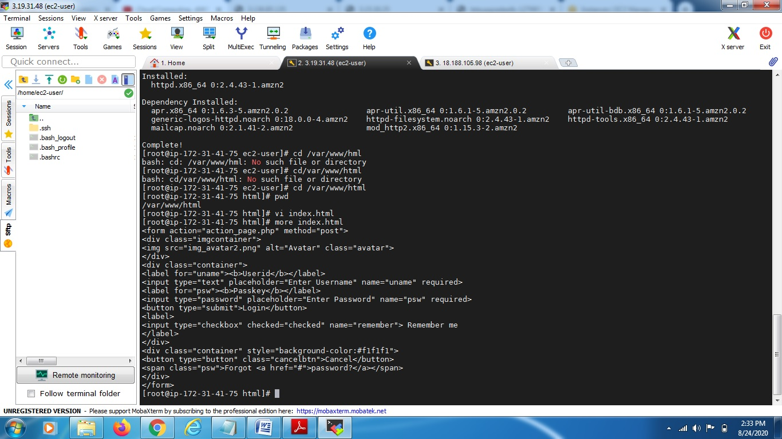

Step 3: Host html login webpage on both servers

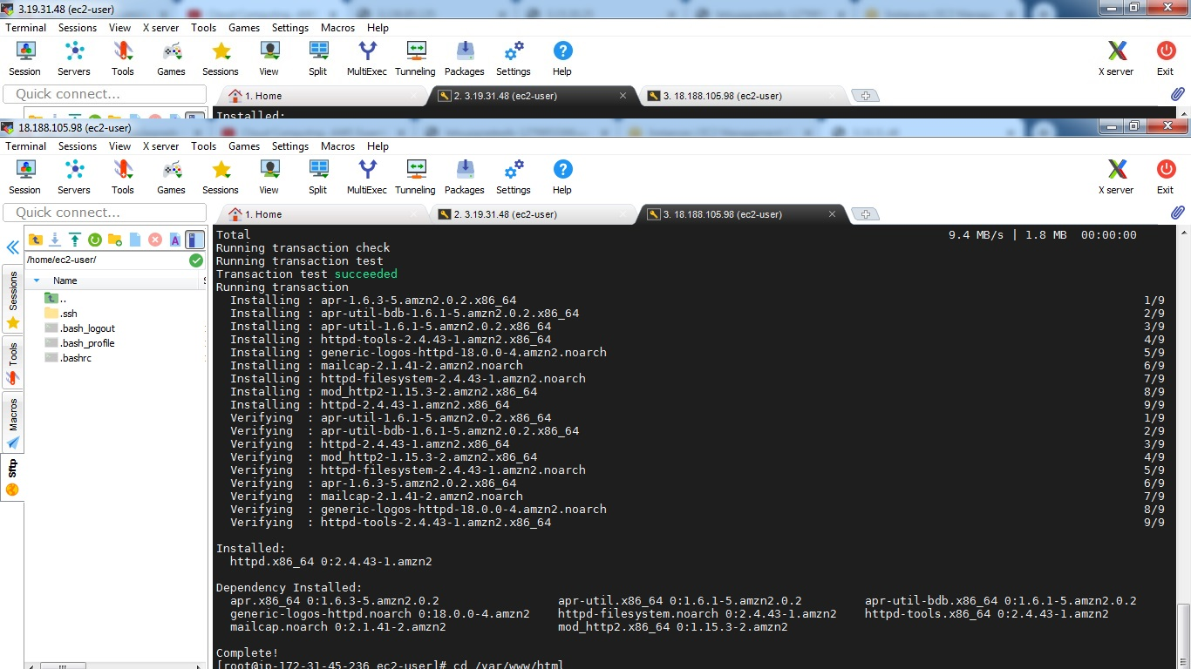

Step4:Check if the application is deployed on both servers by copy pasting the public ip of the servers into the browser.

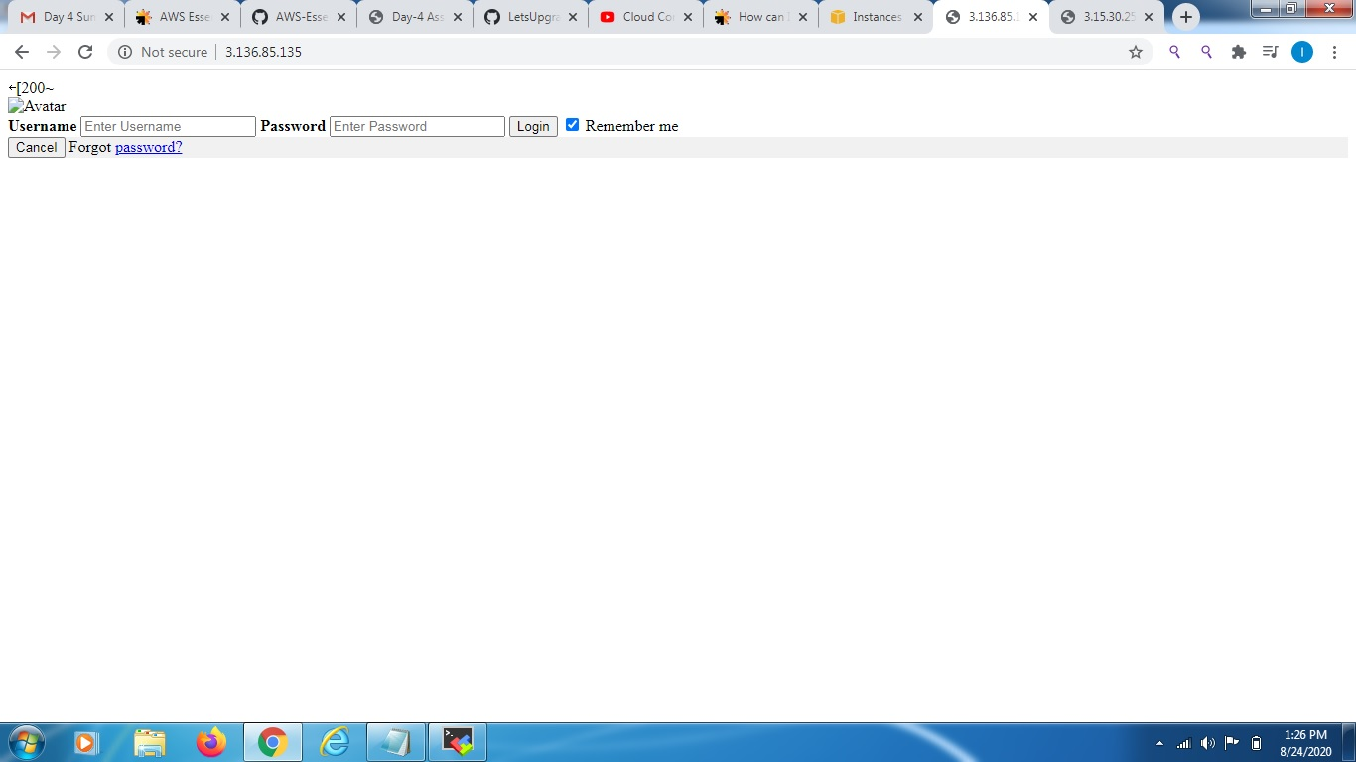

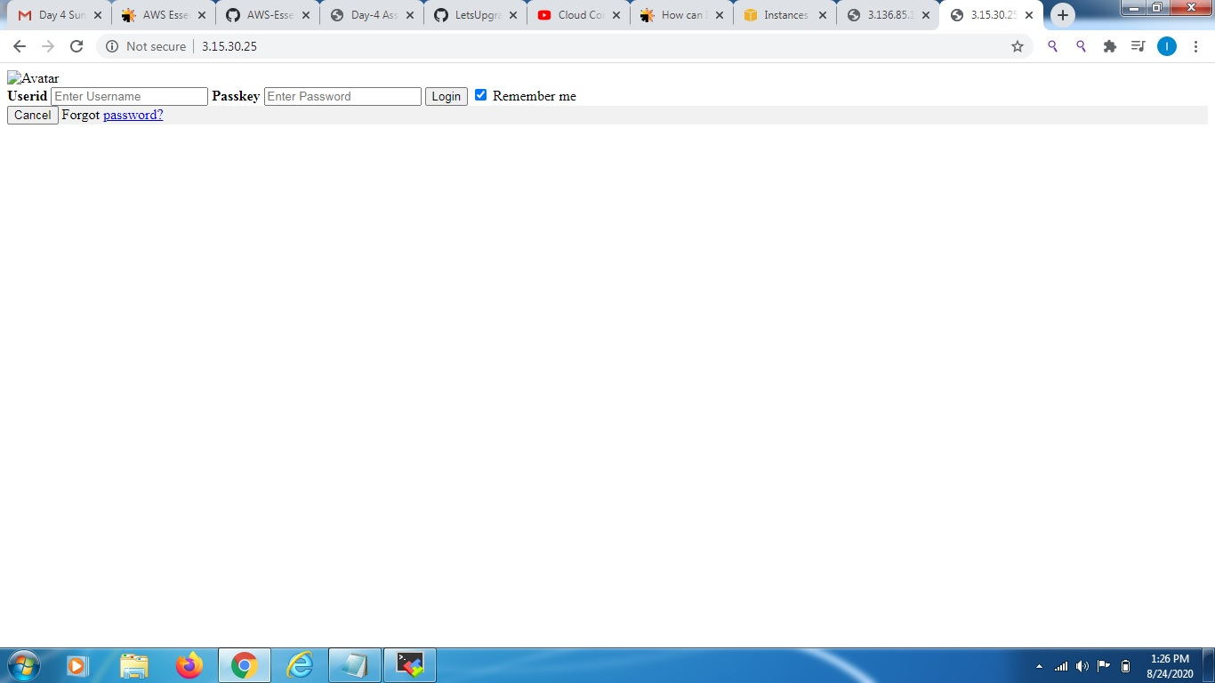

Step5:Create a application Load balancer with the above two instances as targets

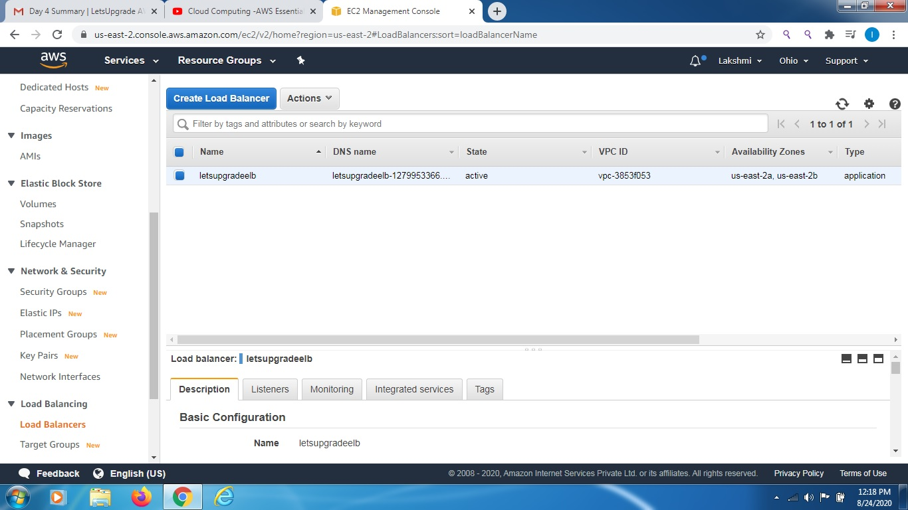

Step6:Check the functioning of ELB

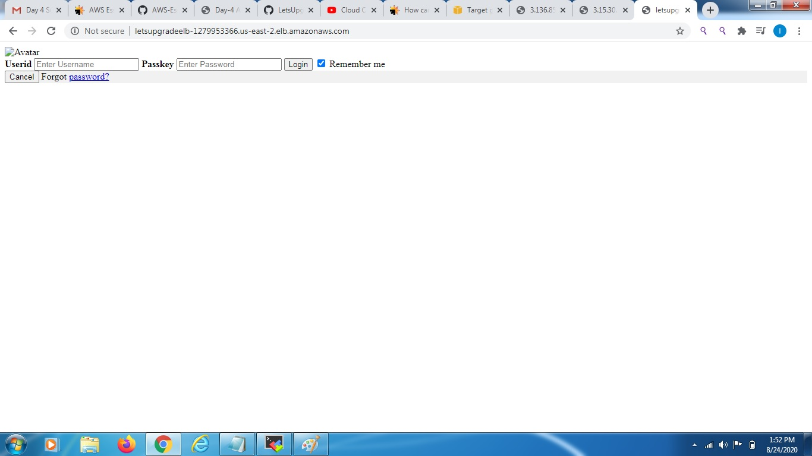

2.

